2) Write with soft pencil lines : Carnival

1. Choose the direction

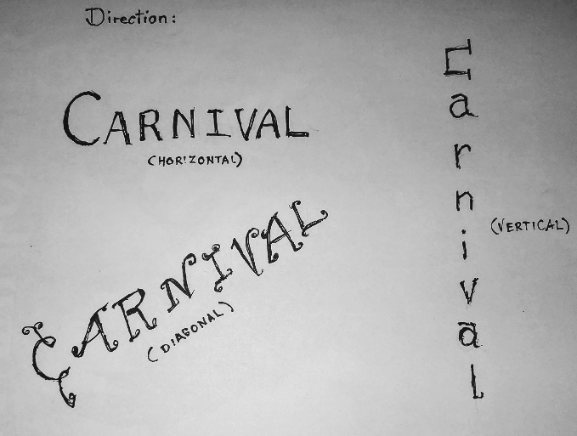 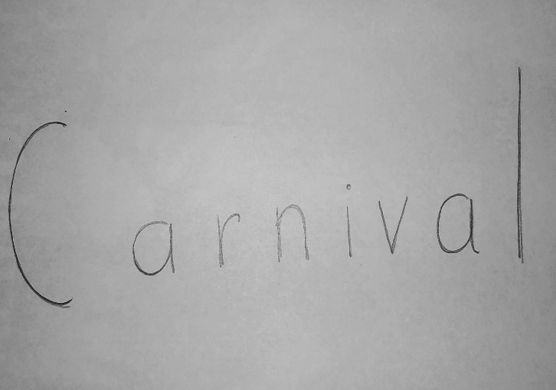

Lesson 1 Carnival Step by Step Instructions by Ursula Majer

4) Erase each letter that is inside

3) Circle around each letter of the word.

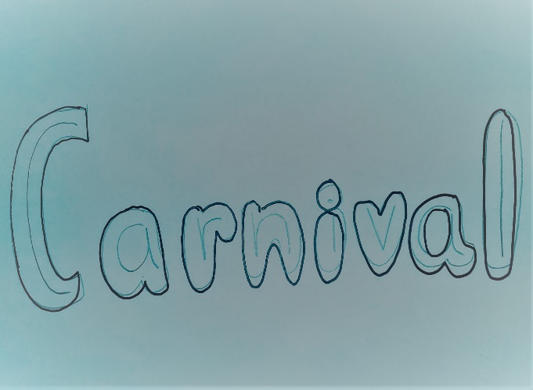 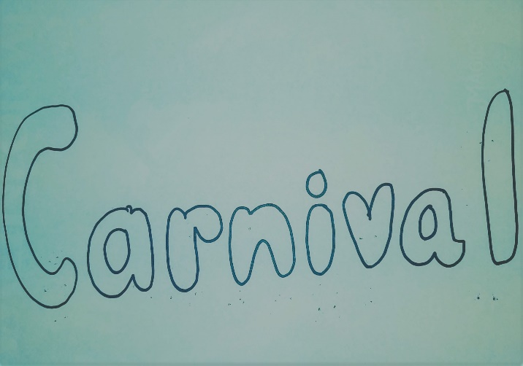

6) Finalize your design and color in using crayons, markers, color pencils, etc.

5) Design fun characters or patterns inside and around the word Carnival

