**Carnival** is a public [festival](https://kids.kiddle.co/Festival) which takes place in many cities and towns in many countries around the world.

It is in February or March each year. Carnival can sometimes last for several weeks. In some places there is only one day of celebration.

There are often street [parades](https://kids.kiddle.co/Parade), [bands](https://kids.kiddle.co/Band), [costumes](https://kids.kiddle.co/Costume) and many people wear [masks](https://kids.kiddle.co/Mask). Carnival is linked to religious [traditions](https://kids.kiddle.co/Tradition) as Lent.

What is

Carnival?

C A R N I V A L- Lesson 1

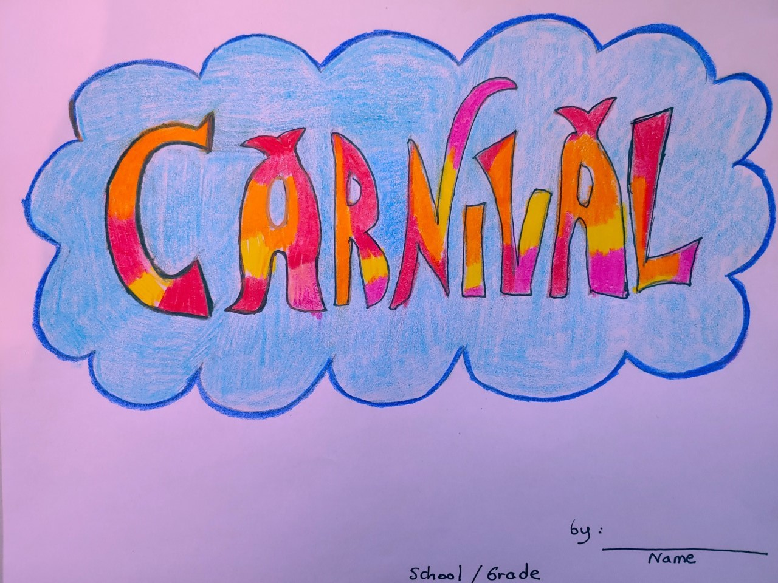

Materials: Pencil, eraser, white paper.

Crayons and/or markers.

Lettering in Art: The way people use calligraphy or lettering is important to bring attention to the public. You are called to create a fun design for the word “Carnival”. Use Mrs Ursula Guide 1 step by step to design this word. You can submit your work online. You can ask an adult in your family to take a picture and send it to my email. I will be very happy to post it.